# **Install and Configure Internet Information Services for Window Server**

**Step 1:** Open Server Manager simply type “Server Manager” with the start menu open, and it should be found in the search.

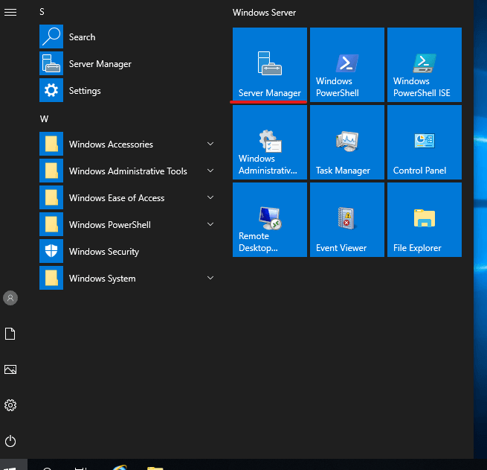

**Step 2**: Wait for it to open, Now click on **ADD ROLE AND FEATURES**

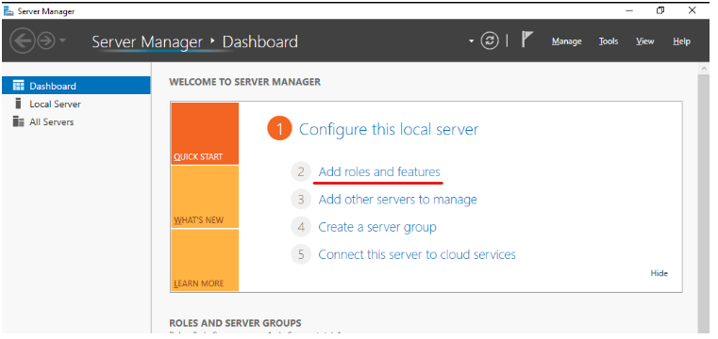

**Step 3:** On the Next screen, click the Next button.

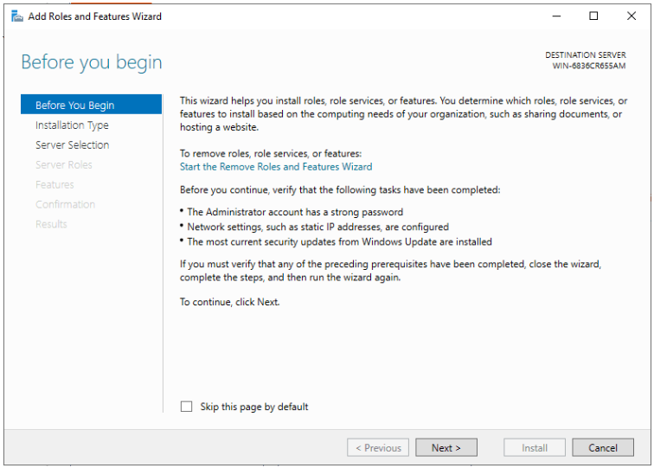

**Step 4:** Select **Role-based or feature-based installation** and click Next.

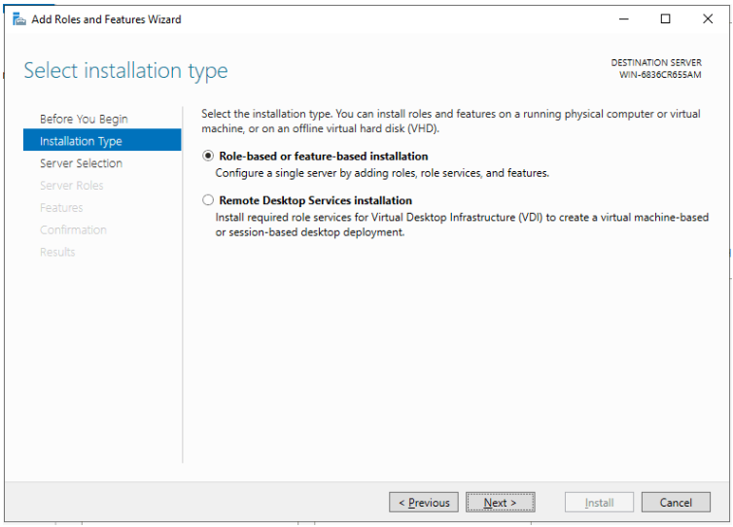

**Step 5:** Select Server from servers list.

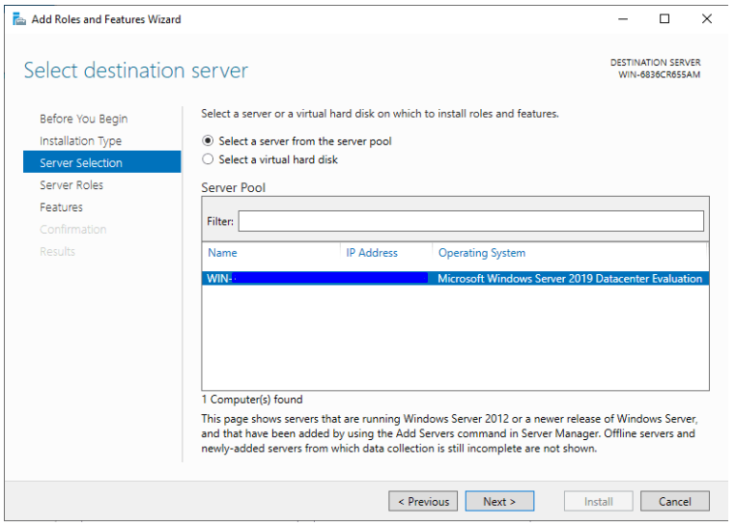

**Step 6:** Click the checkbox “Web Server (IIS)” in the “select server roles” window, a new window will open to specify additional functions, simply click on the ‘Add Features’ button. When done, click Next Button.

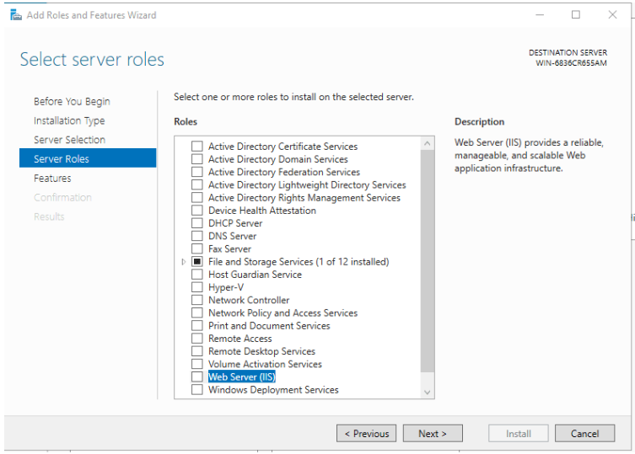

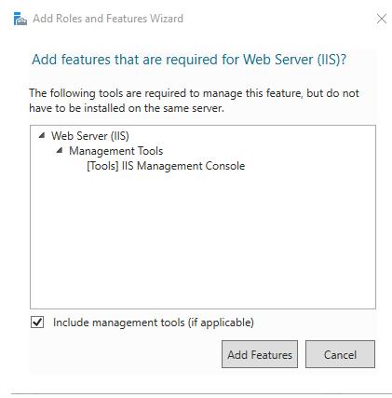

**Step 7:** We won’t install additional features, so just click Next on this window.

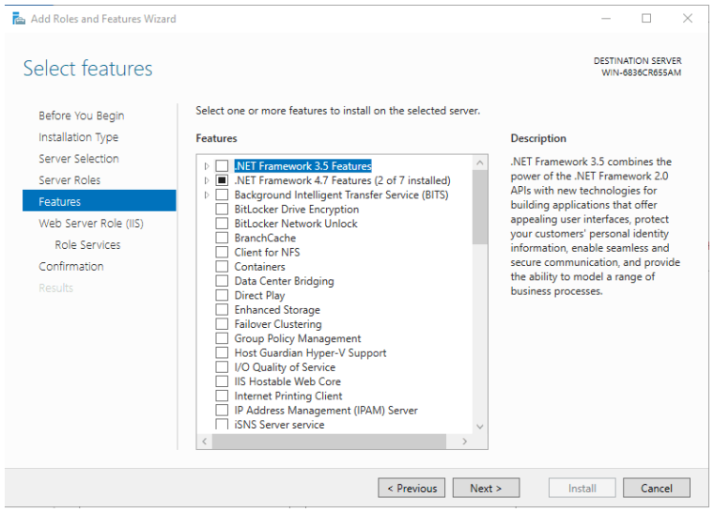

**Step 8:** Click next button again

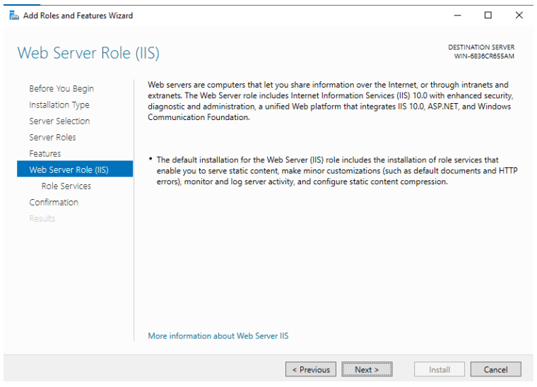

**Step 9:** You can install additional IIS services Now or just click Next to install the defaults.

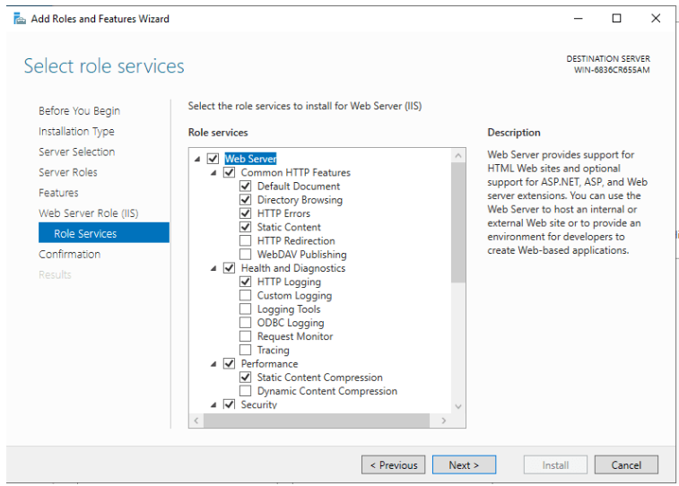

**Step 10:** No reboot should be required with a standard IIS installation, however, if you remove the role a reboot will be needed.

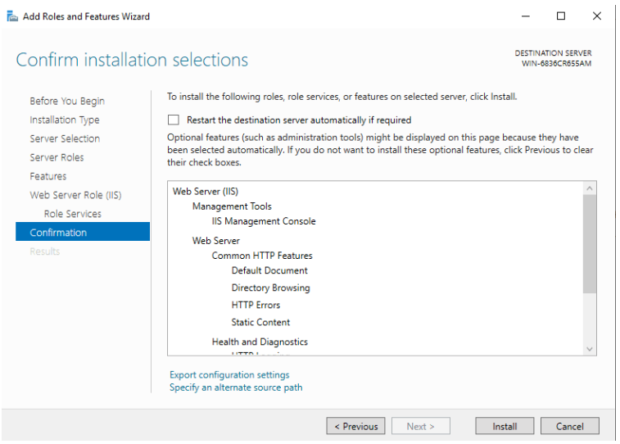

**Step 11:** We just finished installing IIS. Now let’s go to the setup part.

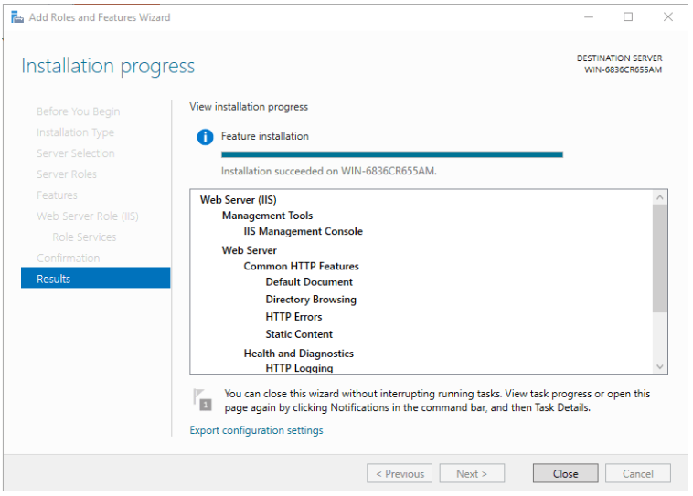

**Step 12:** Open Server Manager, select IIS, right-click the server and select IIS Manager.

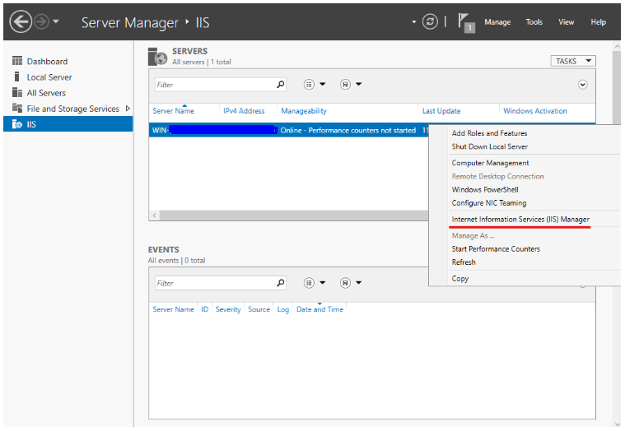

**Step 13:** Right-click the Sites node in the Connections window tree and click Add Site.

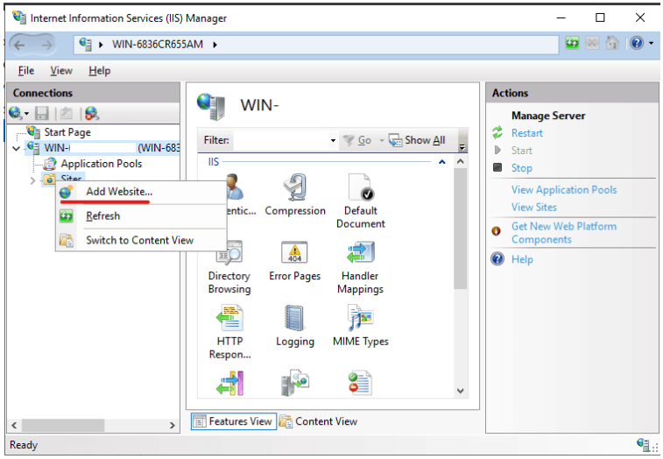

Then expand server and expand sites. And Create site content Folder in C:\inetpub\wwwroot

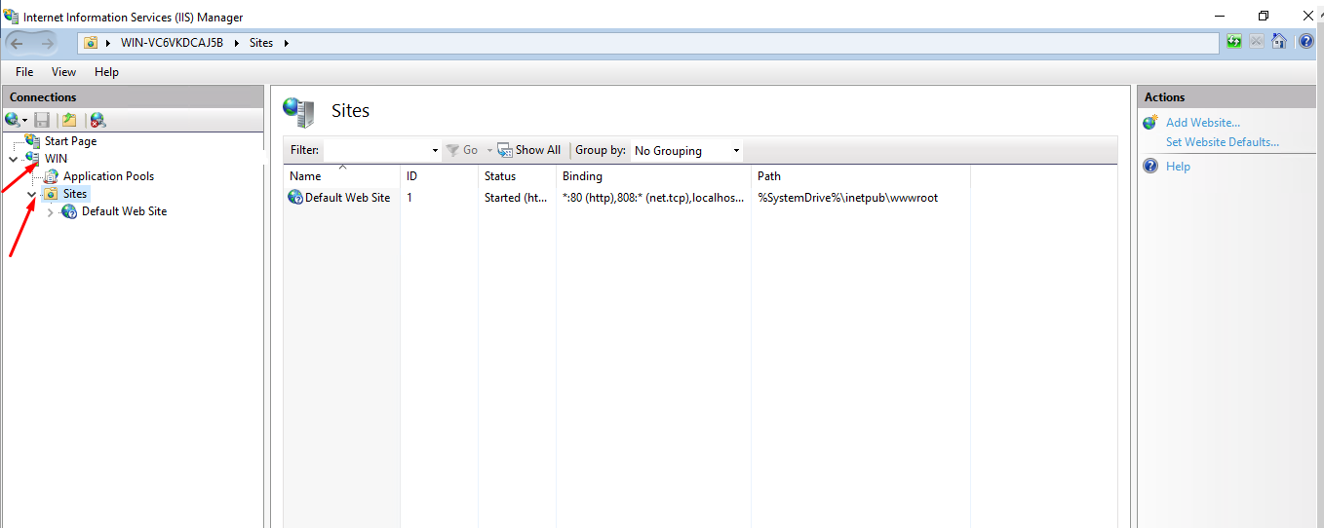

And Create site content Folder in C:\inetpub\wwwroot

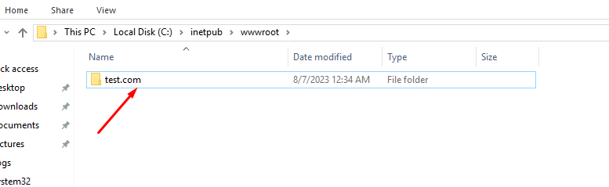

**Step 14:** Right click on sites then click on Add websites.

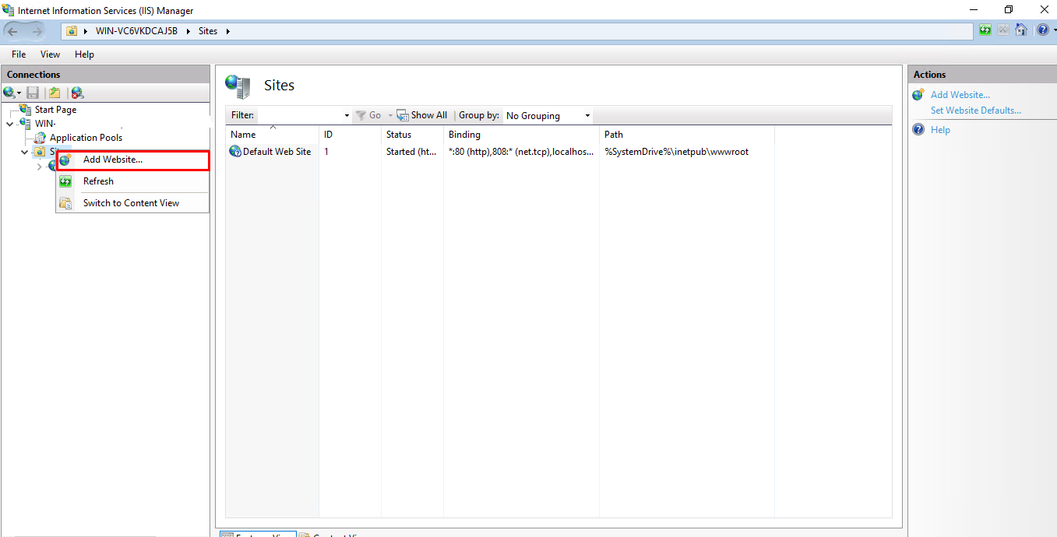

**Step 15:** Give Site name >> Give Physical path of folder >> Give Host name >> Click on ok.

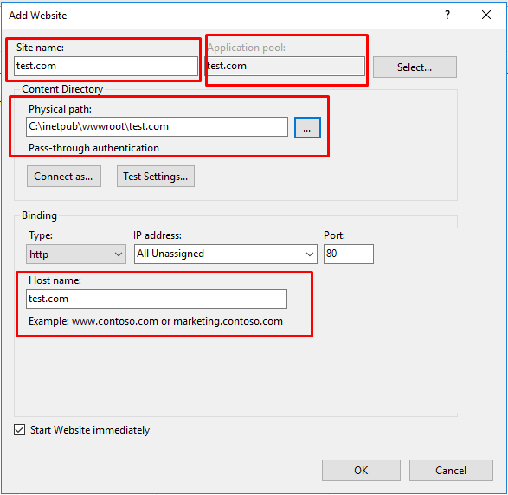

**Step 16:** Open Application pool >> Double click on test.com >> Select .Net CLR version >> Ok

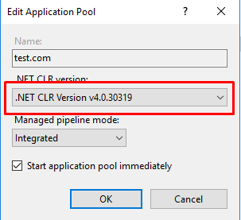

**Step 17:** Right click on site name and click on edit bindings.

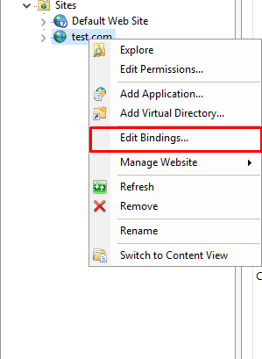

Then click on Add

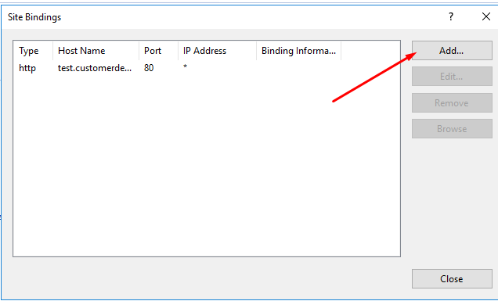

**Step 18:** Change type http to https and Enter the host name. check the box Require server name indication. Select SSL certificate and click on OK button.

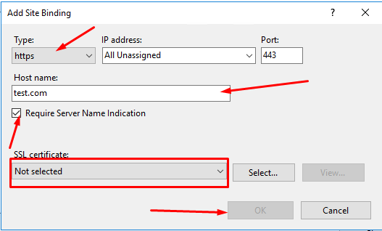

**Step 19:** Database Connection String setup in Site

Open Site folder >> Right click on Appsettings.json >> open with Notepad++

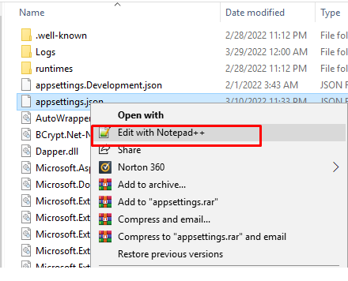

Enter Database details in the connection string and then save the file.



Now the site is ready .

